PROGRAM – 1

AIM
To design a simple static HTML web page using ordered lists, unordered lists, and tables to display student record information.

ALGORITHM
- Start the program.
- Create the basic HTML structure.
- Add ordered and unordered lists.
- Create a table to display student details.
- Save the file with .html extension.
- Run the page in browser.
- Stop the program.

CODE
<!DOCTYPE html>
<html>
<head>
<title>Student Record</title>
</head>
<body>
<h2>Student Subjects</h2>
<ol>
<li>Java</li>
<li>Python</li>
<li>Web Technology</li>
</ol>

<h2>Activities</h2>
<ul>
<li>Sports</li>
<li>Seminar</li>
<li>Workshop</li>
</ul>

<table border="1">
<tr>
<th>Reg No</th>
<th>Name</th>
<th>Department</th>
</tr>
<tr>
<td>101</td>
<td>Arun</td>
<td>CSE</td>
</tr>
</table>
</body>
</html>

OUTPUT
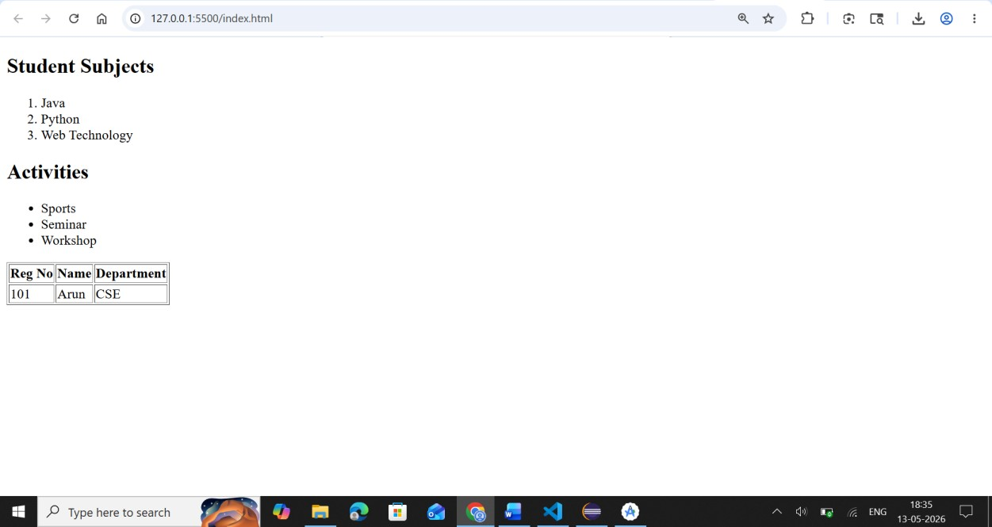

RESULT
Thus the static HTML web page using lists and tables was created successfully.

PROGRAM – 2
AIM
To design static web pages for an online bookstore website.

ALGORITHM
- Start the program.
- Create Home page.
- Create Login page.
- Create Catalogue page.
- Create Registration page.
- Link all pages together.
- Execute in browser.
- Stop the program.

CODE
<!DOCTYPE html>
<html>
<head>
<title>Home Page</title>
</head>
<body>
<h1>Online Book Store</h1>
<a href="login.html">Login</a>
<a href="catalogue.html">Catalogue</a>
<a href="register.html">Register</a>
</body>
</html>

OUTPUT
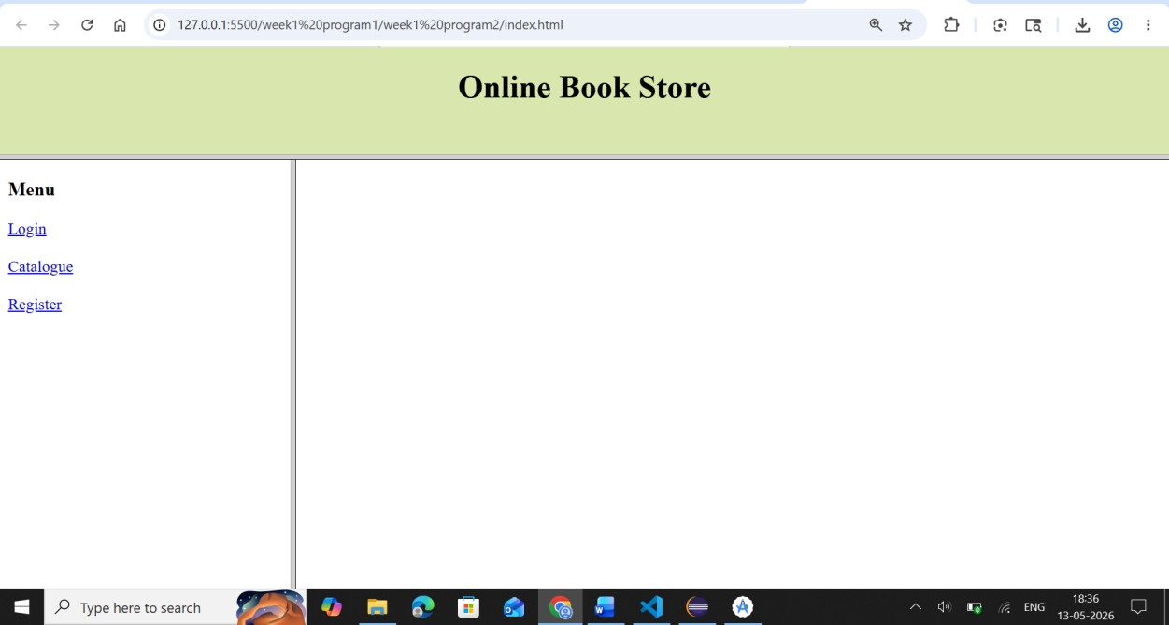
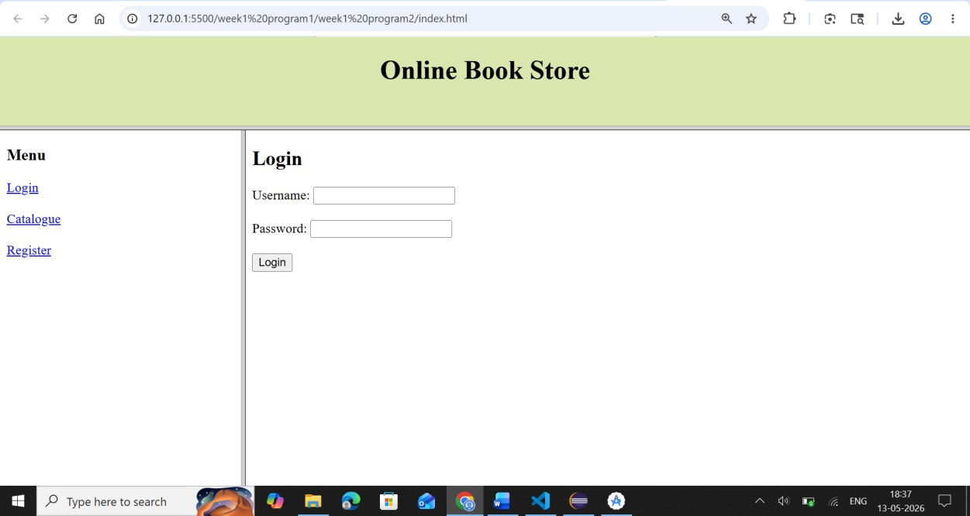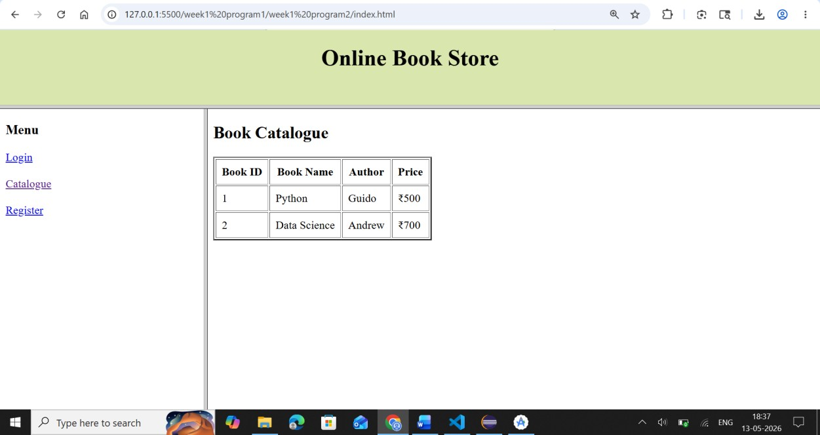
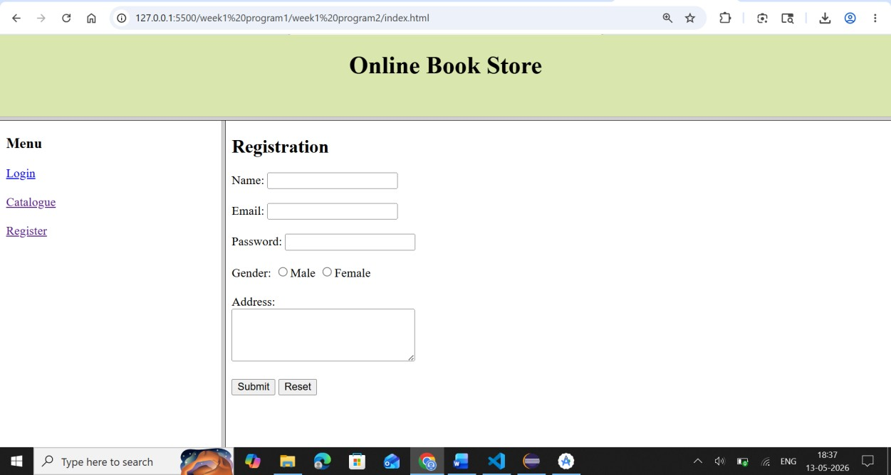

RESULT
Thus the static web pages for online bookstore were designed successfully.

PROGRAM – 3
AIM
To create a web page using HTML form to collect student information.

ALGORITHM
- Start the program.
- Create HTML form.
- Add input fields for student details.
- Add submit button.
- Save and execute the program.
- Stop the program.

CODE
<!DOCTYPE html>
<html>
<head>
<title>Student Form</title>
</head>
<body>
<form>
Name: <input type="text"><br><br>
Email: <input type="email"><br><br>
Branch: <input type="text"><br><br>
Gender:
<input type="radio" name="g">Male
<input type="radio" name="g">Female<br><br>
Address:<br>
<textarea></textarea><br><br>
<input type="submit">
</form>
</body>
</html>

OUTPUT
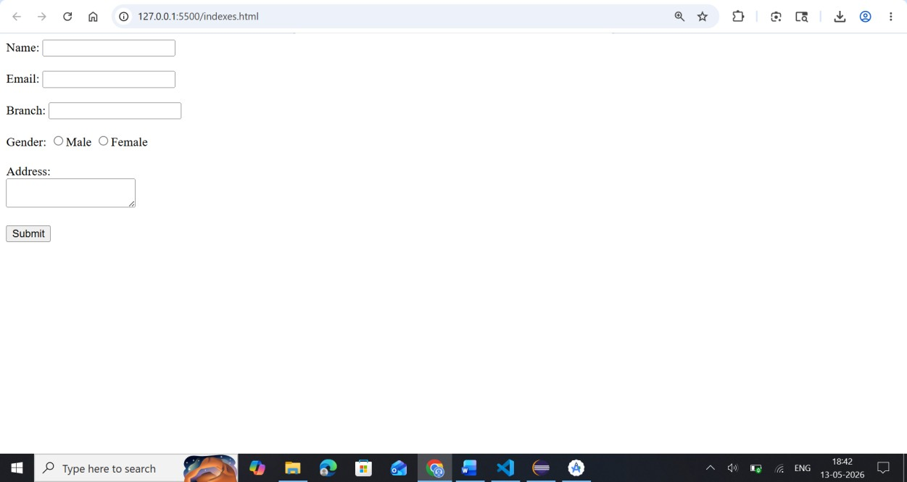

RESULT
Thus the student information form was created successfully.

PROGRAM – 4
AIM
To design a student record web page using CSS keyframe animation.

ALGORITHM
- Start the program.
- Create HTML structure.
- Apply CSS animation using keyframes.
- Execute in browser.
- Verify animation.
- Stop the program.

CODE
<!DOCTYPE html>
<html>
<head>
<style>
@keyframes colorchange { from {background-color: yellow;} to {background-color: orange;}
} div { width: 300px; padding: 20px;
animation: colorchange 3s infinite;
}
</style>
</head>
<body>
<div>
<h2>Student Record</h2>
<p>Name: Arun</p>
</div>
</body>
</html>

OUTPUT
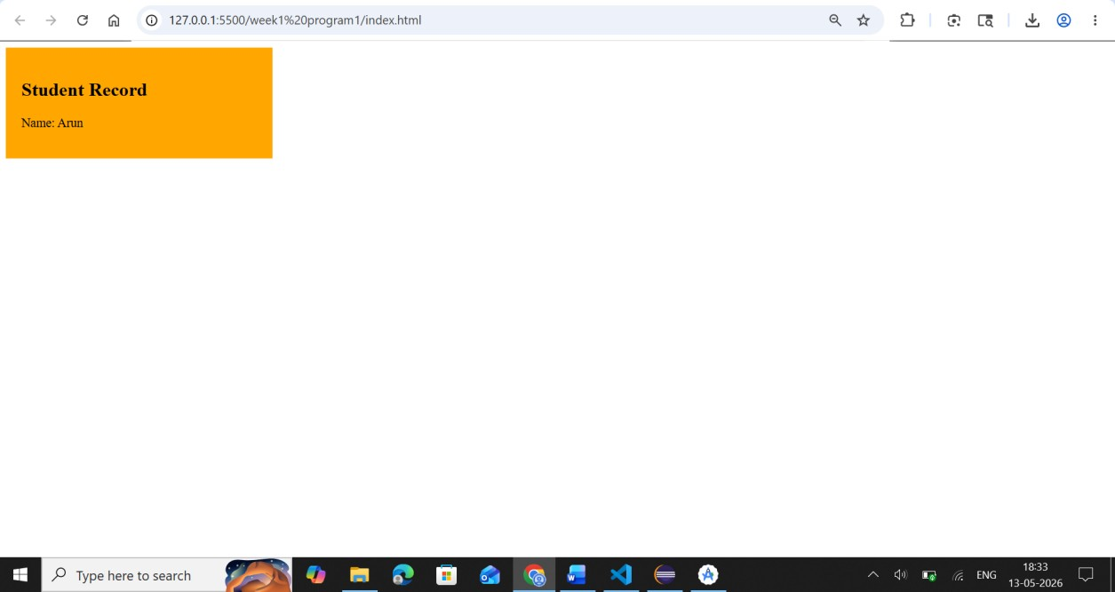

RESULT
Thus the animated student record web page was designed successfully.

PROGRAM – 5
AIM
To validate registration form fields using JavaScript.

ALGORITHM
- Start the program.
- Create HTML form.
- Write JavaScript validation function.
- Validate empty fields.
- Display alert message.
- Execute the program.
- Stop the program.

CODE
<!DOCTYPE html>
<html>
<head>
<script>
function validate(){
var name=document.forms["f1"]["name"].value; if(name==""){
alert("Name cannot be empty"); return false;
}
}
</script>
</head>
<body>
<form name="f1" onsubmit="return validate()">
Name: <input type="text" name="name">
<input type="submit">
</form>
</body>
</html>

OUTPUT
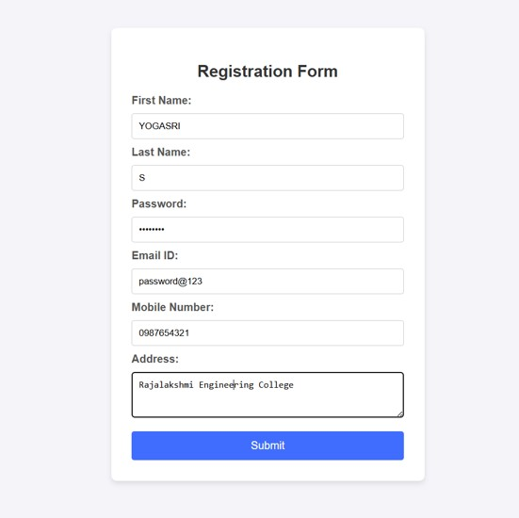

RESULT
Thus the form validation using JavaScript was implemented successfully.

PROGRAM – 6
AIM
To convert numbers from 0 to 999 into words using JavaScript.

ALGORITHM
- Start the program.
- Accept number input.
- Validate range between 0 and 999.
- Convert number into words.
- Display result.
- Stop the program.

CODE
<!DOCTYPE html>
<html>
<head> <script> function convert(){
let n=document.getElementById("num").value; if(n<0 || n>999){
alert("Enter number between 0 and 999");
} else{
document.getElementById("result").innerHTML=n;
}
}
</script>
</head> <body>
Enter Number:
<input type="text" id="num">
<button onclick="convert()">Convert</button>
<p id="result"></p>
</body>
</html>

OUTPUT
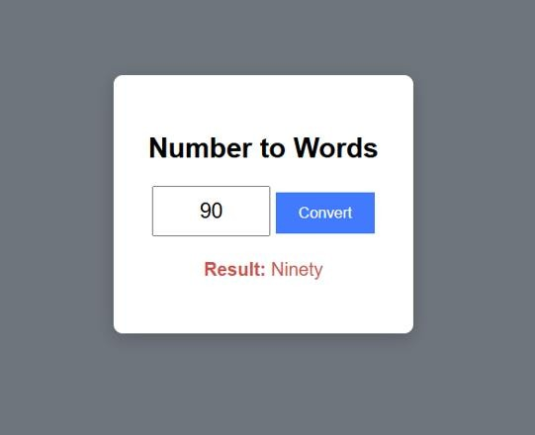

RESULT
Thus the number to words conversion program was executed successfully.

PROGRAM – 7
AIM
To fetch student records in JSON format and display dynamically using JavaScript.

ALGORITHM
- Start the program.
- Create JSON object.
- Access JSON data using JavaScript.
- Display records dynamically.
- Execute the program.
- Stop the program.

CODE
<!DOCTYPE html>
<html>
<body>
<h2>Student Records</h2>
<p id="demo"></p>
<script>
const student={ name:"Arun", regno:"101", dept:"CSE" }; document.getElementById("demo").innerHTML= student.name + " " + student.regno;
</script>
</body>
</html>

OUTPUT
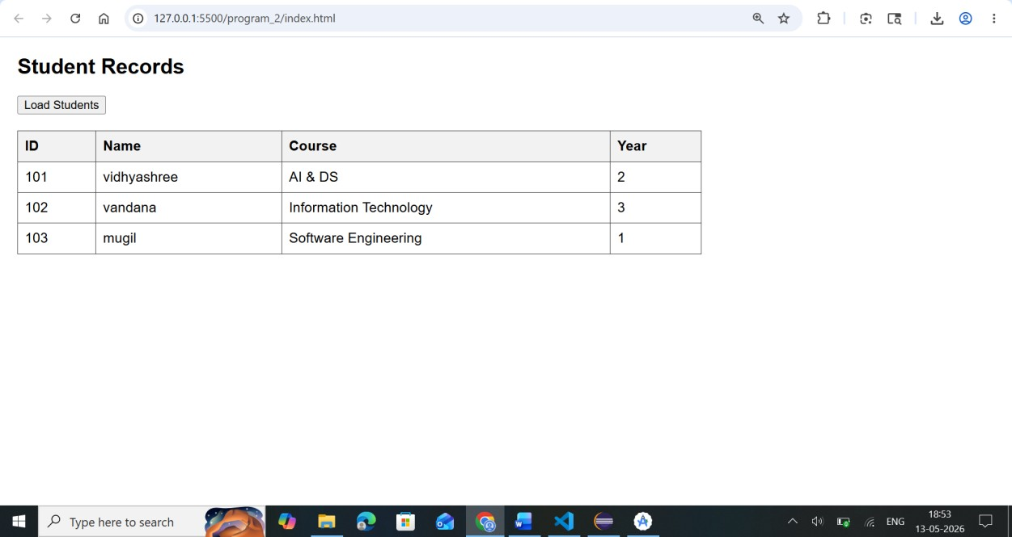

RESULT
Thus the JSON student record display program was executed successfully.

PROGRAM – 8

Aim
To create and run a Hello World Servlet using Eclipse IDE and Apache Tomcat Server.
Software Requirements
- JDK 21
- Eclipse IDE 2025 (Enterprise / Web Developer edition)
- Apache Tomcat Server
- Web Browser (Chrome / Firefox)
Steps to Create Hello World Servlet in Eclipse
Step 1: Start Eclipse IDE
- Open Eclipse IDE 2025.
- Select a Workspace location.
- Click Launch.

Step 2: Create a Dynamic Web Project
- Click File → New → Dynamic Web Project.
- Enter the Project Name as HelloServletApp 3. Select Target Runtime → Apache Tomcat Server.
- Keep default settings.
- Click Finish.
Step 3: Project Structure Created by Eclipse
After creating the project, Eclipse generates the following structure:
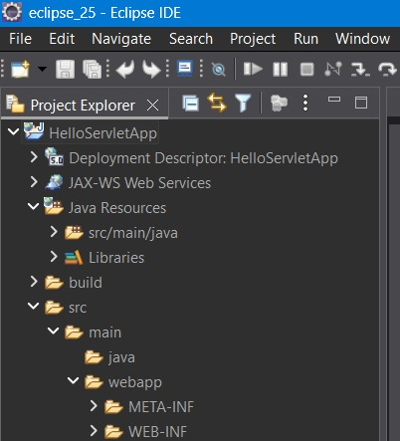

Step 4: Create a Servlet Class
- Right click the project - HelloServletApp
- Select New → Servlet.
- Enter the following details:
Field Value
Package Name - com.example
Class Name - HelloServlet
- Click Next
- Keep default URL mapping:
/HelloServlet
- Click Finish.
Eclipse automatically creates the servlet file:
HelloServlet.java
⚠ Important:
Servlet programs must always be saved with .java extension.
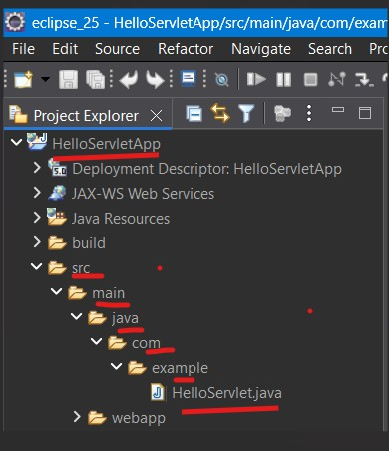
Step 5: Double click on the servlet “HelloServlet.java“ add the below Servlet Code in the file under doGet method
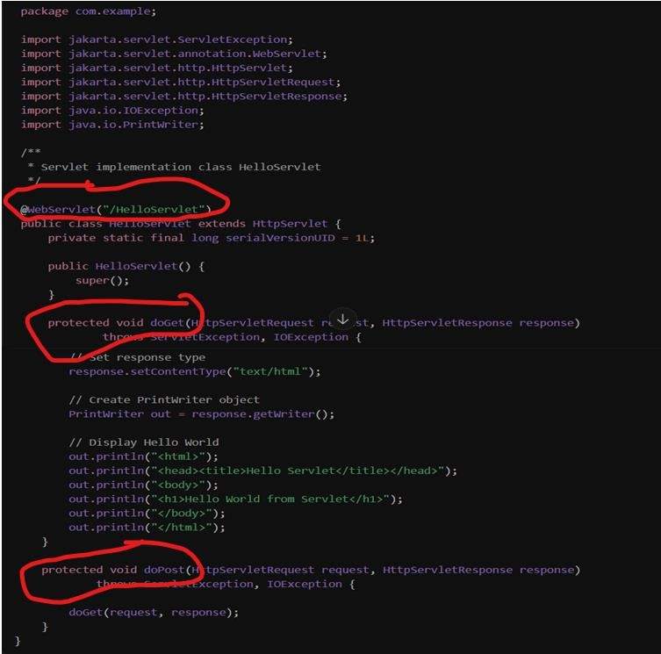
Type this content in HelloServlet.java under the get method as above diagram
// Set response type response.setContentType("text/html");

// Create PrintWriter object
PrintWriter out = response.getWriter();

// Display Hello World out.println("<html>"); out.println("<head><title>Hello Servlet</title></head>"); out.println("<body>"); out.println("<h1>Hello World from Servlet</h1>"); out.println("</body>"); out.println("</html>");

Step 6: Run the Project on Server 1. Right click the project - HelloServletApp
- Select Run As → Run on Server.
- Choose Apache Tomcat Server.
- Click Finish.
Tomcat server will start automatically.

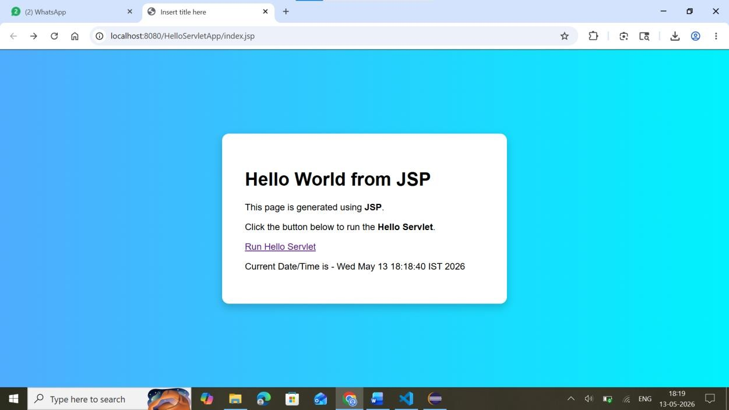
OUTPUT

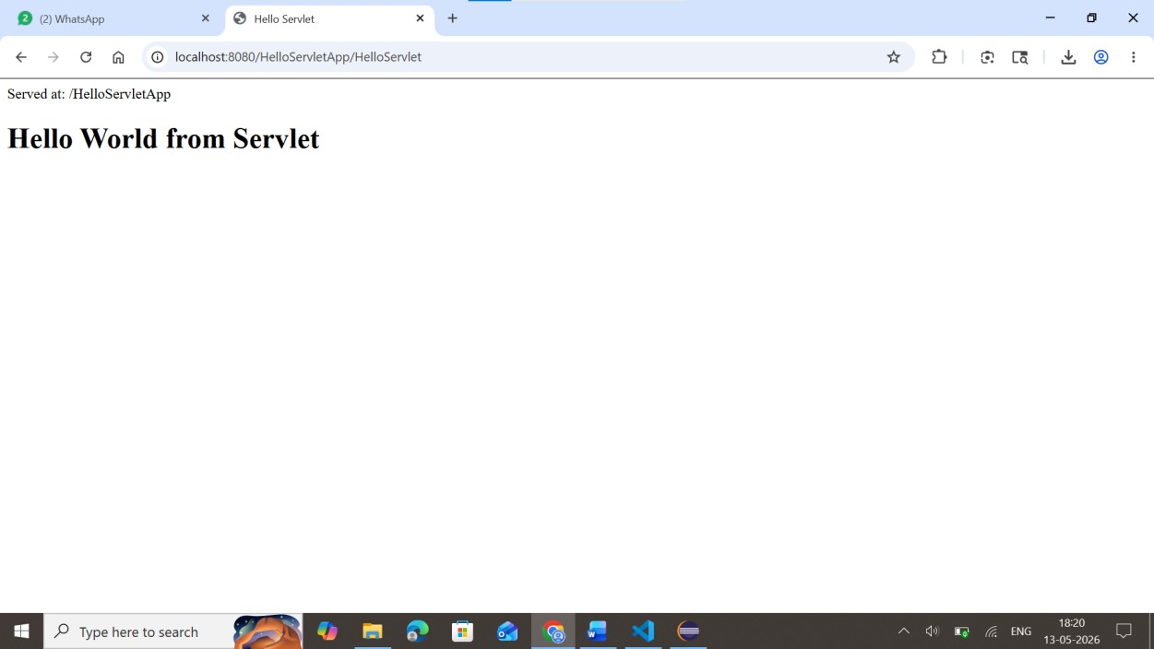

RESULT
The servlet program was executed successfully for printing text using Eclipse and apache tomcat.

PROGRAM – 9

AIM
To create a JSP web page that accepts user input through an HTML form and displays the submitted data using both GET and POST methods.

ALGORITHM
Method 1 – Using GET Method
- Start the program.
- Create a JSP file.
- Design an HTML form inside the JSP page.
- Add input fields such as Name and Department.
- Set the form method as GET.
- Add a submit button to the form.
- Enter the user details in the form.
- Click the submit button.
- The entered data is appended to the URL.
- Retrieve the entered values using request.getParameter().
- Display the submitted values on the JSP page.
- Stop the program.

Method 2 – Using POST Method
- Start the program.
- Create a JSP file.
- Design an HTML form with required input fields.
- Set the form method as POST.
- Add a submit button.
- Enter the user details in the form.
- Click the submit button.
- The form data is sent securely without displaying in the URL.
- Retrieve the form values using request.getParameter().
- Store the values in variables.
- Display the submitted data on the web page.
- Verify the output.
- Stop the program.

STEPS TO EXECUTE THE PROGRAM
- Open Apache Tomcat Server.
- Create a new Dynamic Web Project in Eclipse/NetBeans.
- Create a JSP file named index.jsp.
- Type the JSP and HTML code.
- Save the file.
- Start the Tomcat Server.
- Run the JSP application on the server.
- Enter the required details in the form.
- Click the Submit button.
- View the submitted data displayed on the browser.

CODE
HTML FORM CODE
<html>
<head>
<title>GET and POST Method Example</title>
</head>

<body>

<h2>Student Form Using GET Method</h2>

<form action="StudentServlet" method="get">

Name :
<input type="text" name="name"><br><br>

Department :
<input type="text" name="dept"><br><br>

<input type="submit" value="Submit Using GET">

</form>

<hr>

<h2>Student Form Using POST Method</h2>

<form action="StudentServlet" method="post">

Name :
<input type="text" name="name"><br><br>

Department :
<input type="text" name="dept"><br><br>

<input type="submit" value="Submit Using POST">

</form>

</body>
</html>

SERVLET CODE USING doGet() AND doPost()
import java.io.*; import javax.servlet.*; import javax.servlet.http.*; import javax.servlet.annotation.WebServlet;

@WebServlet("/StudentServlet")

public class StudentServlet extends HttpServlet
{

public void doGet(HttpServletRequest request, HttpServletResponse response) throws ServletException, IOException {

response.setContentType("text/html");

PrintWriter out = response.getWriter();

String name = request.getParameter("name");
String dept = request.getParameter("dept");

out.println("<html>"); out.println("<body>");

out.println("<h2>Student Details Using GET Method</h2>");

out.println("<p>Name : " + name + "</p>"); out.println("<p>Department : " + dept + "</p>");

out.println("</body>"); out.println("</html>");
}

public void doPost(HttpServletRequest request, HttpServletResponse response) throws ServletException, IOException
{

response.setContentType("text/html");

PrintWriter out = response.getWriter();

String name = request.getParameter("name");
String dept = request.getParameter("dept");

out.println("<html>"); out.println("<body>");

out.println("<h2>Student Details Using POST Method</h2>");

out.println("<p>Name : " + name + "</p>"); out.println("<p>Department : " + dept + "</p>"); out.println("</body>"); out.println("</html>");
}
}

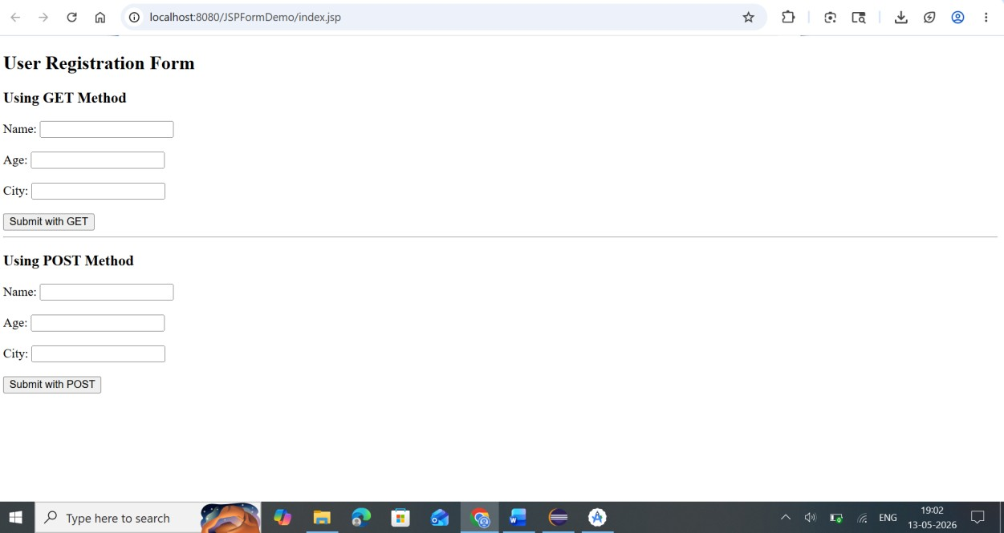
OUTPUT

RESULT
Thus the Servlet program using doGet() and doPost() methods with Web Annotation was executed successfully.

PROGRAM – 10

AIM
To develop a calculator application using JSP and Servlet.
Step 1: Create Dynamic Web Project
- Open Eclipse
- Go to
File → New → Dynamic Web Project

3. Project Name: CalculatorServletApp
- Target Runtime: Apache Tomcat
- Click Finish

Step 2: Create Calculator JSP Page
Inside webapp, create - calculator.jsp
- Right click the webapp Folder under the project CalculatorServletApp
- Select New → jsp File , file structure as below

Code
Type the below content for calculator.jsp

<%@ page language="java" contentType="text/html; charset=UTF-8" %>
<!DOCTYPE html>
<html>
<head>
<title>Simple Calculator</title>
</head>

<body>
<h2>Simple Calculator</h2>
<form action="calculate" method="post"> Number 1:
<input type="text" name="num1"><br><br>

Number 2:
<input type="text" name="num2"><br><br>

Operation:
<select name="operation">
<option value="add">Addition</option>
<option value="sub">Subtraction</option>
<option value="mul">Multiplication</option>
<option value="div">Division</option>
</select>

<br><br>
<input type="submit" value="Calculate">
</form>
<br> <%
if(request.getAttribute("result") != null)
{
%>

<h3>Result = <%= request.getAttribute("result") %></h3>

<%
}
%>

</body>
</html>

Step 3: Create Servlet
- Right click the project - CalculatorServletApp
- Select New → Servlet.
- Enter the following details:
Field | Value
Package Name - | com.example
Class Name - | CalculatorServlet
- Click Next
- Keep default URL mapping:
/CalculatorServlet
- Click Finish.
Eclipse automatically creates the servlet file:
CalculatorServlet.java
Step 4: Write Servlet Code CalculatorServlet.java package com.example;

import java.io.IOException; import javax.servlet.*; import javax.servlet.http.*; import javax.servlet.annotation.WebServlet;

@WebServlet("/calculate")
public class CalculatorServlet extends HttpServlet {

protected void doPost(HttpServletRequest request, HttpServletResponse response) throws ServletException, IOException {

double num1 = Double.parseDouble(request.getParameter("num1")); double num2 = Double.parseDouble(request.getParameter("num2"));
String operation = request.getParameter("operation");

double result = 0;

if(operation.equals("add")) result = num1 + num2;

else if(operation.equals("sub")) result = num1 - num2;

else if(operation.equals("mul")) result = num1 * num2;

else if(operation.equals("div")) result = num1 / num2;

request.setAttribute("result", result);

RequestDispatcher rd = request.getRequestDispatcher("calculator.jsp"); rd.forward(request, response);

}
}

Step 4: Run the Calculator Application file on Browser
1. Right click the calculator.jsp 2. Select Run As → Run on Server.
- Choose Apache Tomcat Server.
- Click Finish.
Tomcat server will open the calculator.jsp file in browser

OUTPUT
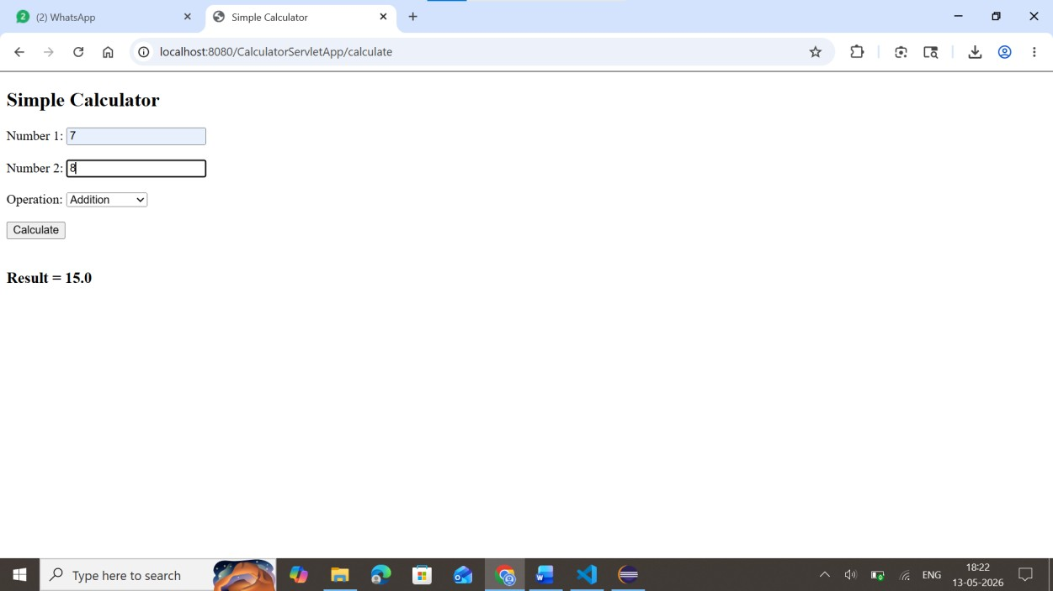
RESULT
The Simple Calculator web application was successfully developed using JSP and Servlet.

PROGRAM – 11

AIM
To develop a Servlet program that demonstrates session tracking using HttpSession by implementing a simple login system and maintaining user session information.

Algorithm
- Start the program.
- Display the login page to the user.
- User enters username and password.
- The form sends data to LoginServlet.
- The servlet retrieves the login credentials using request.getParameter().
- Validate the username and password.
- If the credentials are correct:
o Create a session using HttpSession session = request.getSession(); o Store username in session using session.setAttribute().
- Forward the request to welcome.jsp.
- Display the welcome message using session data.
- Provide a link to Session Information Page.
- The session information page retrieves session attributes using getAttribute().
- Display session details such as:
- Username
- Session ID
- Session creation time
13. Stop.
HTML LOGIN PAGE
<html>
<head>
<title>Login Page</title>
</head>

<body>

<h2>Login Form</h2>

<form action="LoginServlet" method="post">

User Name :
<input type="text" name="username"><br><br>

Password :
<input type="password" name="password"><br><br>

<input type="submit" value="Login">

</form>

</body>
</html>

SERVLET PROGRAM USING HttpSession
import java.io.*; import javax.servlet.*; import javax.servlet.http.*;
import javax.servlet.annotation.WebServlet;

@WebServlet("/LoginServlet")

public class LoginServlet extends HttpServlet
{ public void doPost(HttpServletRequest request, HttpServletResponse response) throws ServletException, IOException
{
response.setContentType("text/html");

PrintWriter out = response.getWriter();

String uname = request.getParameter("username");
String pass = request.getParameter("password");

if(uname.equals("admin") && pass.equals("1234"))
{

HttpSession session = request.getSession();
session.setAttribute("user", uname);
out.println("<html>"); out.println("<body>");

out.println("<h2>Login Successful</h2>");
out.println("<p>Welcome : " + uname + "</p>");

out.println("<p>Session ID : " + session.getId() + "</p>");
out.println("</body>"); out.println("</html>");
} else {
out.println("<html>");
out.println("<body>");

out.println("<h2>Invalid Username or Password</h2>");
out.println("</body>"); out.println("</html>");
}
}
}

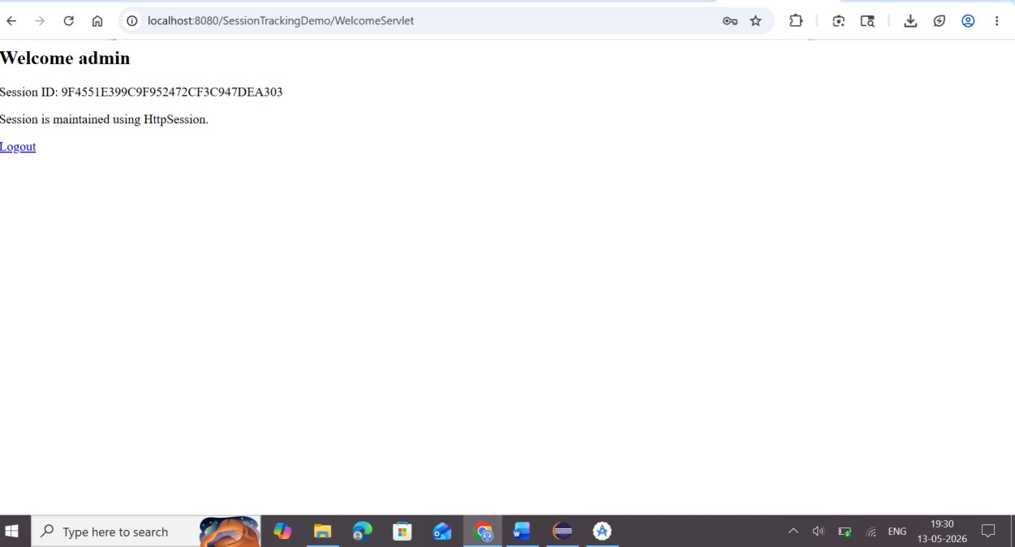
OutPut

RESULT
Thus the servlet program demonstrating session tracking using HttpSession was executed successfully.

PROGRAM – 12

AIM
To develop a simple Android application using Java and Empty Views Activity that displays Hello World text and a Button in the Android Emulator..

Software Requirements
- Android Studio
- Java JDK
- Android Emulator / Virtual Device

Algorithm
- Start Android Studio.
- Create a new project.
- Select Empty Views Activity.
- Choose Java as the programming language.
- Open activity_main.xml.
- Add TextView and Button components.
- Arrange them using ConstraintLayout.
- Save the project.
- Run the application in the Android Emulator.
- Verify the output.

Steps
- Open Android Studio.
- Click New Project.
- Select Empty Views Activity and click Next.
- Enter the following details:
- Name: HelloWorldApp
- Package Name: com.example.helloworldapp
- Language: Java
- Minimum SDK: API 21 or above
- For Build Configuration language → select Groovy DSL(Build.Gradle)
- Click Finish.
- Open the file:

res → layout → activity_main.xml
- Add TextView and Button widgets.
- Connect the widgets using constraints.
- Save the file.
- Click Run.
- Choose Android Emulator.

Res -> layout -> activity_main.xml

<?xml version="1.0" encoding="utf-8"?> <androidx.constraintlayout.widget.ConstraintLayout xmlns:android="http://schemas.android.com/apk/res/android" xmlns:app="http://schemas.android.com/apk/res-auto" xmlns:tools="http://schemas.android.com/tools" android:id="@+id/main" android:layout_width="match_parent" android:layout_height="match_parent" tools:context=".MainActivity">

<Button android:id="@+id/btnHello" android:layout_width="wrap_content" android:layout_height="wrap_content" android:text="Hello World" app:layout_constraintTop_toTopOf="parent" app:layout_constraintBottom_toBottomOf="parent" app:layout_constraintStart_toStartOf="parent" app:layout_constraintEnd_toEndOf="parent" /> <TextView android:id="@+id/textMyWorld" android:layout_width="wrap_content" android:layout_height="wrap_content" android:text="This is my world" android:textColor="#FF0000" android:textSize="18sp" app:layout_constraintTop_toBottomOf="@id/btnHello" app:layout_constraintStart_toStartOf="parent" app:layout_constraintEnd_toEndOf="parent" android:layout_marginTop="16dp"/>

</androidx.constraintlayout.widget.ConstraintLayout>

MainActivity.java
package com.example.helloworldapp;

import androidx.appcompat.app.AppCompatActivity; import android.os.Bundle;

public class MainActivity extends AppCompatActivity {

@Override protected void onCreate(Bundle savedInstanceState) { super.onCreate(savedInstanceState); setContentView(R.layout.activity_main);
} }

OUTPUT
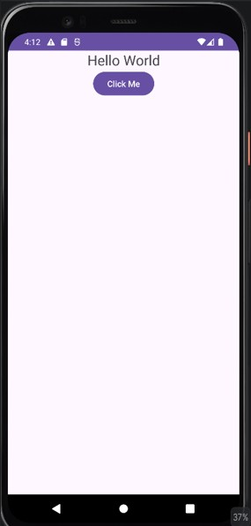

RESULT
Thus, an Android application using Java and Empty Views Activity was successfully developed to display Hello World text and a Button and executed in the Android Emulator.

PROGRAM – 13

AIM
To develop an Android application that performs basic arithmetic operations (Addition, Subtraction, Multiplication, Division) using Button, EditText, and TextView controls and run the application in the Android Emulator.

Calculator Application
In this experiment:
- Two EditText fields accept numbers from the user.
- Four Buttons perform arithmetic operations.
- A TextView displays the result.

Algorithm
- Start Android Studio.
- Create a new project using Empty Views Activity.
- Select Java as the programming language.
- Open activity_main.xml.
- Add two EditText fields for number inputs.
- Add four Buttons for operations.
- Add a TextView to display the result.
- Write Java code to perform arithmetic operations.
- Run the application in the Android Emulator.
- Verify that the calculator performs operations correctly.

Steps
- Open Android Studio.
- Click New Project.
- Select Empty Views Activity.
- Enter the following details:
- Name: CalculatorApp
- Language: Java
- Minimum SDK: API 21 or above
- For Build Configuration language → select Groovy DSL(Build.Gradle)
- Click Finish.
- Open the layout file:

res → layout → activity_main.xml
7. Add the following UI components:
- Two EditText fields
- Four Buttons (Add, Subtract, Multiply, Divide)
- One TextView for result display
- Open MainActivity.java.
- Write Java code to perform arithmetic operations.
- Run the application using the Android Emulator.

Code
activity_main.xml

<EditText android:id="@+id/num1" android:hint="Enter First Number" android:inputType="numberDecimal" android:layout_width="0dp" android:layout_height="wrap_content" app:layout_constraintTop_toTopOf="parent" app:layout_constraintStart_toStartOf="parent" app:layout_constraintEnd_toEndOf="parent"/>

<EditText android:id="@+id/num2" android:hint="Enter Second Number" android:inputType="numberDecimal" android:layout_width="0dp" android:layout_height="wrap_content" app:layout_constraintTop_toBottomOf="@id/num1" app:layout_constraintStart_toStartOf="parent" app:layout_constraintEnd_toEndOf="parent" android:layout_marginTop="10dp"/>

<Button android:id="@+id/add" android:text="Addition" android:layout_width="0dp" android:layout_height="wrap_content" app:layout_constraintTop_toBottomOf="@id/num2" app:layout_constraintStart_toStartOf="parent" app:layout_constraintEnd_toEndOf="parent" android:layout_marginTop="10dp"/>

<Button android:id="@+id/sub" android:text="Subtraction" android:layout_width="0dp" android:layout_height="wrap_content" app:layout_constraintTop_toBottomOf="@id/add" app:layout_constraintStart_toStartOf="parent" app:layout_constraintEnd_toEndOf="parent" android:layout_marginTop="10dp"/>

<Button android:id="@+id/mul" android:text="Multiplication" android:layout_width="0dp" android:layout_height="wrap_content" app:layout_constraintTop_toBottomOf="@id/sub" app:layout_constraintStart_toStartOf="parent" app:layout_constraintEnd_toEndOf="parent" android:layout_marginTop="10dp"/>

<Button android:id="@+id/div" android:text="Division" android:layout_width="0dp" android:layout_height="wrap_content" app:layout_constraintTop_toBottomOf="@id/mul" app:layout_constraintStart_toStartOf="parent" app:layout_constraintEnd_toEndOf="parent" android:layout_marginTop="10dp"/>

<TextView android:id="@+id/result" android:text="Result" android:textSize="20sp" android:layout_width="wrap_content" android:layout_height="wrap_content" app:layout_constraintTop_toBottomOf="@id/div" app:layout_constraintStart_toStartOf="parent" android:layout_marginTop="20dp"/>

MainActivity.java package com.example.calculatorapp;

import androidx.appcompat.app.AppCompatActivity; import android.os.Bundle; import android.view.View; import android.widget.Button; import android.widget.EditText; import android.widget.TextView;

public class MainActivity extends AppCompatActivity {

EditText num1, num2;
Button add, sub, mul, div;
TextView result;

@Override protected void onCreate(Bundle savedInstanceState) { super.onCreate(savedInstanceState); setContentView(R.layout.activity_main);

num1 = findViewById(R.id.num1); num2 = findViewById(R.id.num2);

add = findViewById(R.id.add); sub = findViewById(R.id.sub); mul = findViewById(R.id.mul); div = findViewById(R.id.div);

result = findViewById(R.id.result);

add.setOnClickListener(v -> calculate('+')); sub.setOnClickListener(v -> calculate('-')); mul.setOnClickListener(v -> calculate('*')); div.setOnClickListener(v -> calculate('/'));
}

private void calculate(char operator) {

double n1 = Double.parseDouble(num1.getText().toString()); double n2 = Double.parseDouble(num2.getText().toString()); double res = 0;

switch(operator) {
case '+':
res = n1 + n2;
break;
case '-': res = n1 - n2; break;
case '*': res = n1 * n2; break;
case '/': res = n1 / n2; break;
}

result.setText("Result: " + res);
}
}

OUTPUT
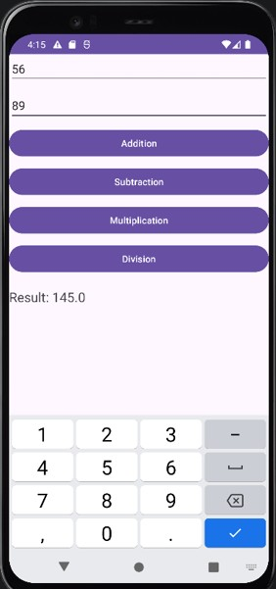

RESULT
Thus, an Android application was successfully developed using Java, EditText, Button, and TextView controls to perform basic calculator operations and executed in the Android Emulator.

PROGRAM – 14

AIM
To develop an Android application to change the font style and color of the text and display a Toast message when the button is pressed.

ALGORITHM
- Start the program.
- Open Android Studio.
- Create a new Android project using Empty Views Activity.
- Design the layout using TextView and Button controls.
- Assign an ID for the TextView and Button.
- Open the Java file and initialize the controls using findViewById().
- Set a click listener for the Button.
- Inside the button click event:
  - Change the text color using setTextColor(). o Change the text size using setTextSize().
  - Change the font style using setTypeface().
- Display a Toast message using Toast.makeText().
- Run the application in Android Emulator.
- Verify the output.
- Stop the program.

CODE
activity_main.xml
<?xml version="1.0" encoding="utf-8"?>

<LinearLayout
xmlns:android="http://schemas.android.com/apk/res/android" android:layout_width="match_parent" android:layout_height="match_parent"
android:orientation="vertical" android:gravity="center"
android:padding="20dp">

<TextView
android:id="@+id/textView" android:layout_width="wrap_content" android:layout_height="wrap_content" android:text="Welcome to Android" android:textSize="24sp"
android:textStyle="bold"/>

<Button
android:id="@+id/button" android:layout_width="wrap_content" android:layout_height="wrap_content" android:text="Change Style" android:layout_marginTop="20dp"/>

</LinearLayout>

MainActivity.java
package com.example.toastapp;

import androidx.appcompat.app.AppCompatActivity;

import android.graphics.Color; import android.graphics.Typeface; import android.os.Bundle; import android.view.View; import android.widget.Button; import android.widget.TextView; import android.widget.Toast;

public class MainActivity extends AppCompatActivity
{

TextView textView;
Button button;

@Override
protected void onCreate(Bundle savedInstanceState)
{
super.onCreate(savedInstanceState);

setContentView(R.layout.activity_main);

textView = findViewById(R.id.textView); button = findViewById(R.id.button);

button.setOnClickListener(new View.OnClickListener()
{
@Override
public void onClick(View v)
{

textView.setTextColor(Color.RED);

textView.setTextSize(30);

textView.setTypeface(null, Typeface.ITALIC);

Toast.makeText(getApplicationContext(),
"Button Pressed",
Toast.LENGTH_SHORT).show();
}
});
} }

OUTPUT
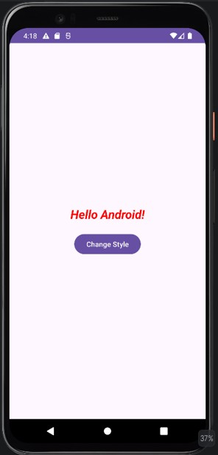

RESULT
Thus the Android application to change the font style and color of the text and display a Toast message was developed and executed successfully.

